**Name: VISHNU SADASIVAN**

**Roll No: 52**

**Batch:MCA**

**Date:25-03-22**

**ADVANCED DBMS LAB**

**Experiment No.: 1**

**Aim**

To study various DDL commands – CREATE, INSERT

**QUESTION**

Create the following Tables and Insert values.

**Table 1: DEPOSIT**

CREATE TABLE DEPOSITE

(ACTNO VARCHAR(5) CHECK (ACTNO LIKE'D%') PRIMARY KEY,

CNAME VARCHAR(20) REFERENCES CUSTOMER (CNAME) ,

BNAME VARCHAR(20) REFERENCES BRANCH(BNAME),

AMOUNT FLOAT(8) CHECK(AMOUNT>0) NOT NULL,

ADATE DATE);

**Table 2: BRANCH**

CREATE TABLE BRANCH (BNAME VARCHAR(20) PRIMARY KEY,

CITY VARCHAR(30) CHECK(CITY IN('NAGPUR','DELHI','BANGALORE','BOMBAY'))NOT NULL);

**Table 3: CUSTOMER**

CREATE TABLE CUSTOMER(CNAME VARCHAR(15) PRIMARY KEY,

CITY VARCHAR(20) NOT NULL);

**Table 4: BORROW**

CREATE TABLE BORROW (LOANNO VARCHAR(8) CHECK (LOANNO LIKE 'L%') PRIMARY KEY,

CNAME VARCHAR(15) REFERENCES CUSTOMER(CNAME) ,

BNAME VARCHAR(20) REFERENCES

BRANCH(BNAME),AMOUNT FLOAT(8) CHECK (AMOUNT>0) NOT NULL);

**PROCEDURE**

1. **Deposit Table (Create and Insert)**

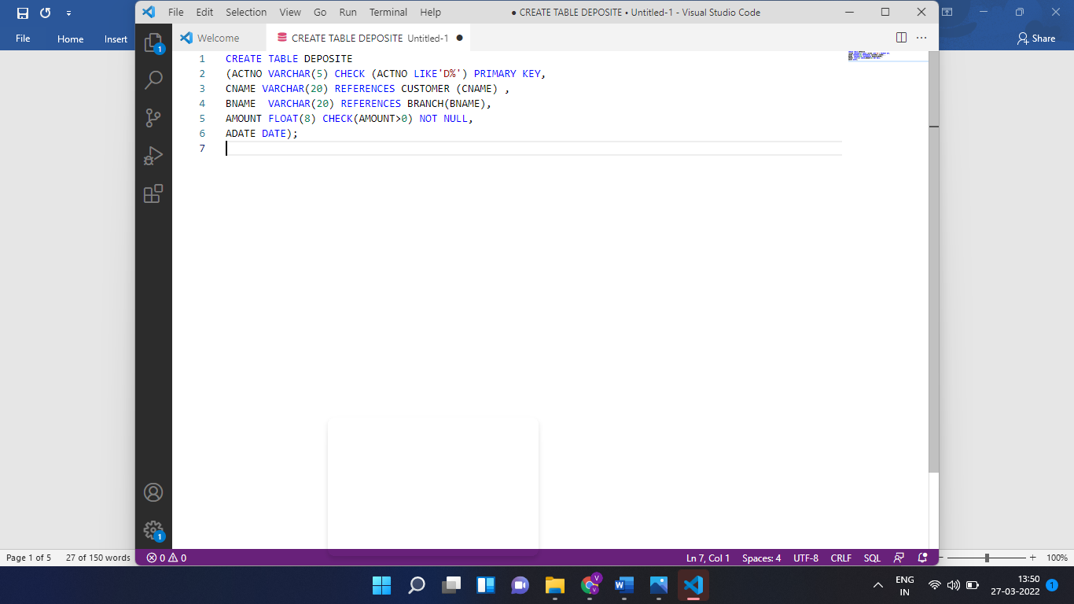

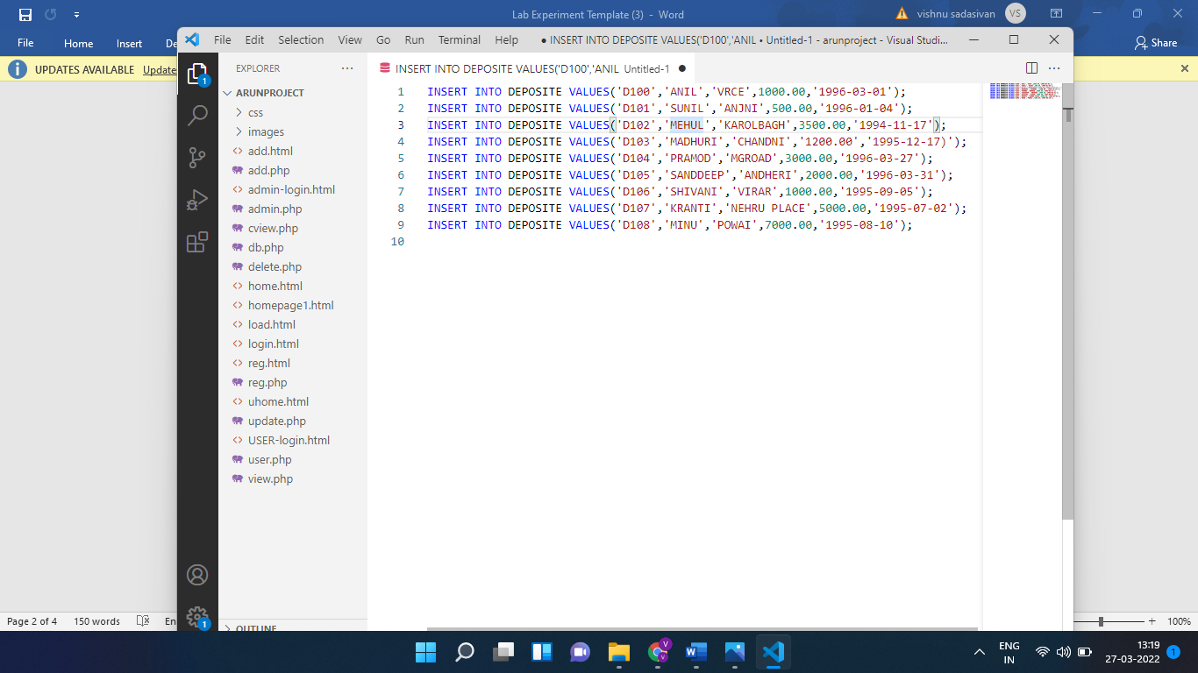

1. **Branch Table(Create and Insert)**

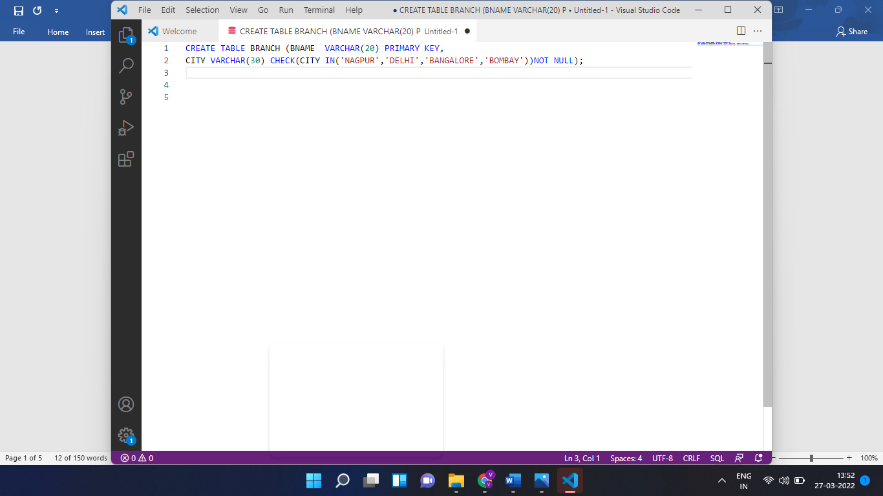

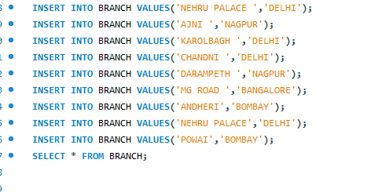

1. **Customer Table(Create and Insert)**

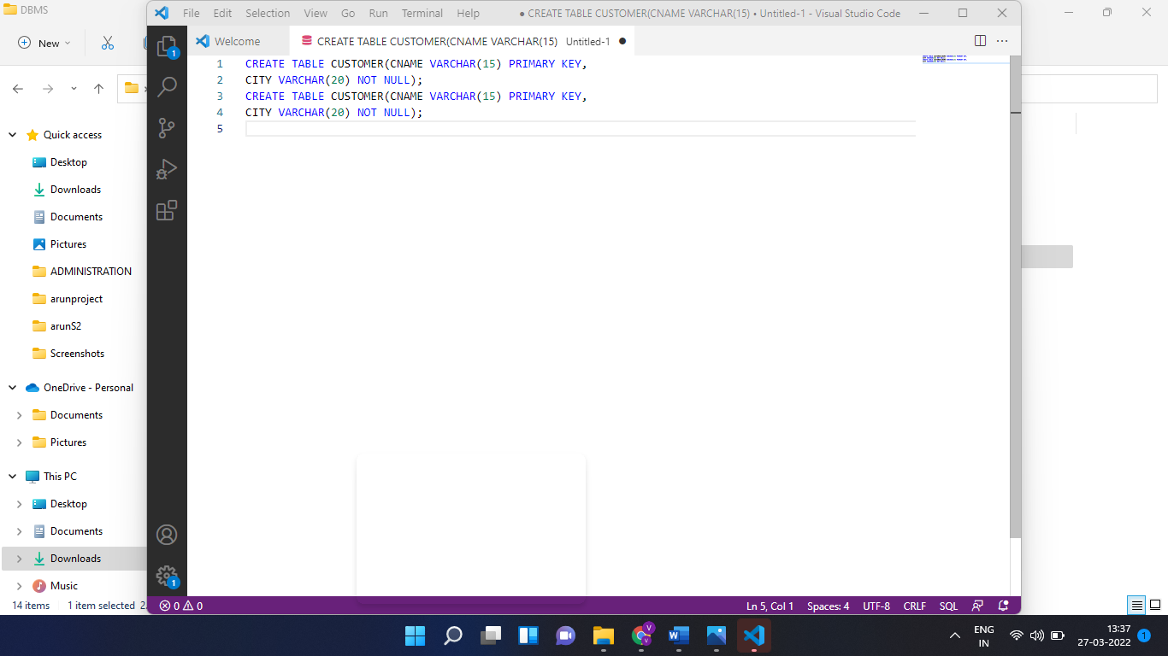

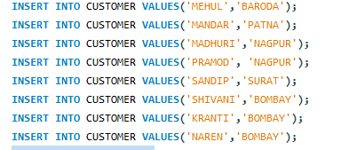

1. **Borrow Table (Create and Insert)**

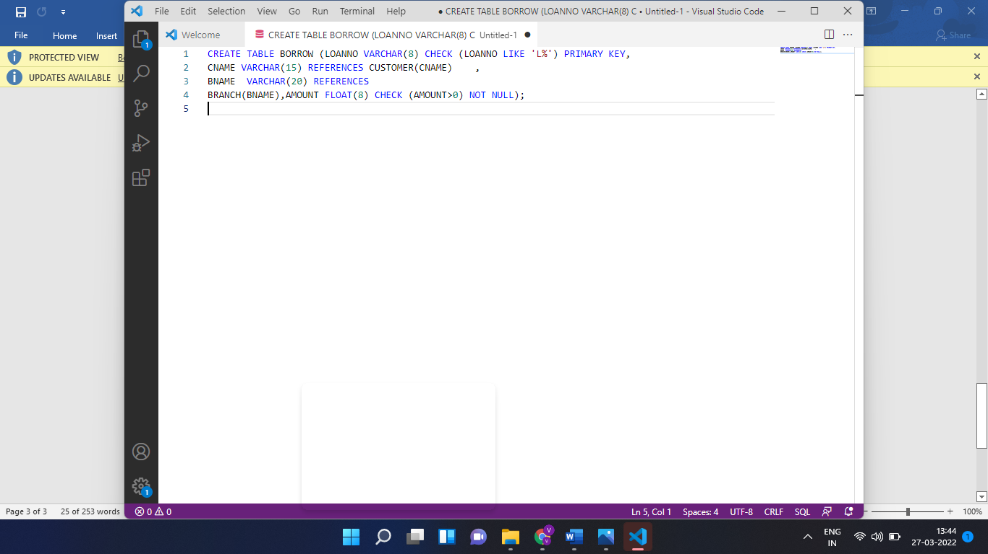

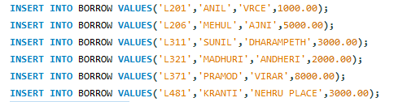

**Output Screenshot**

1. **Deposite Table**

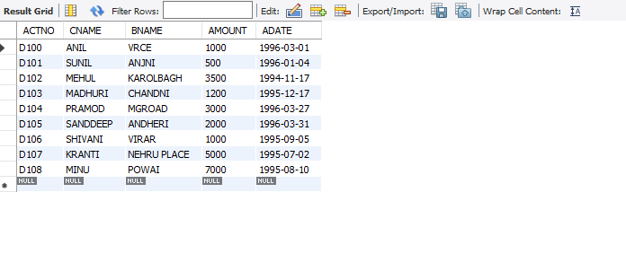

1. **Branch Table**

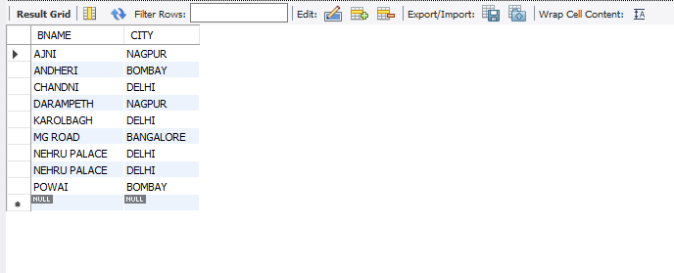

1. **CUSTOMER TABLE**

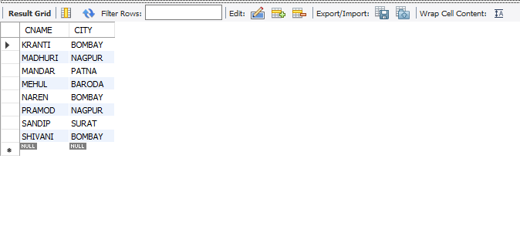

1. **BORROW TABLE**

